Roll number 2k21/MKIT/03

Name Areeba Saleem

03 Assignment

Of python programing

Given by Sir Muhammad Hanif

Task 1

dict= {"name": 'Areeba', "DoB": '27/12/2001', "RollNo": '03', "Marks": 89}

print(dict)

Output

{'name': 'Areeba', 'DoB': '27/12/2001', 'RollNo': '03', 'Marks': 89}

In [21]:

series= pd.Series(dict)

print(series)

output

name Areeba

DoB 27/12/2001

RollNo 03

Marks 89

dtype: object

In [ ]:

Snapshot

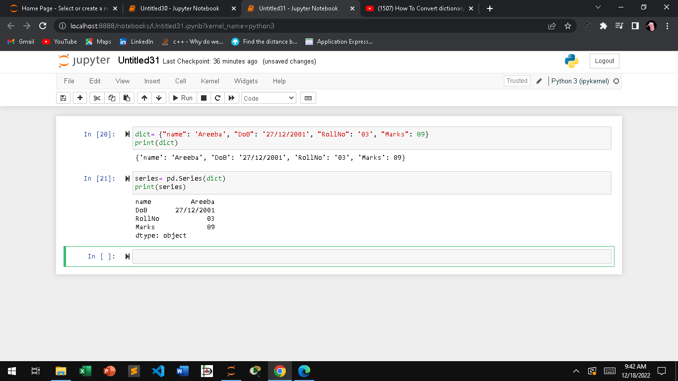

Task 2

(a)

data= {'players': ['Areeba','Maram', 'savera', 'Bilal'],

'Runs':[35, 30,2,56],

'balls': [22,27,2,58],

'Minutes': [32,24,6,65],

'Dots': [6,3,1,13]}

df = pd.DataFrame(data)

type(df)

df.sort_values(by=['Runs'])

output

| **players** | **Runs** | **balls** | **Minutes** | **Dots** |
| --- | --- | --- | --- | --- |
| **2** | savera | 2 | 2 | 6 | 1 |
| **1** | Maram | 30 | 27 | 24 | 3 |
| **0** | Areeba | 35 | 22 | 32 | 6 |
| **3** | Bilal | 56 | 58 | 65 | 13 |

my_columns=["players","Runs"]

df[my_columns]

Output

| **players** | **Runs** |
| --- | --- |
| **0** | Areeba | 35 |
| **1** | Maram | 30 |
| **2** | savera | 2 |
| **3** | Bilal | 56 |
|  |  |  |

In [ ]:

Task 2

(b)

df=pd.DataFrame(data,columns=["players","Runs","balls", "Minutes", "Dots"],

index=["one","two", "three","four"])

df

Output

| **players** | **Runs** | **balls** | **Minutes** | **Dots** |
| --- | --- | --- | --- | --- |
| **one** | Areeba | 35 | 22 | 32 | 6 |
| **two** | Maram | 30 | 27 | 24 | 3 |
| **three** | savera | 2 | 2 | 6 | 1 |
| **four** | Bilal | 56 | 58 | 65 | 13 |

In [72]:

df.loc[["one","four"]]

Output

| **players** | **Runs** | **balls** | **Minutes** | **Dots** |
| --- | --- | --- | --- | --- |
| **one** | Areeba | 35 | 22 | 32 | 6 |
| **four** | Bilal | 56 | 58 | 65 | 13 |

In [ ]:

